Otranto come via di pellegrinaggio (XHina Fejzaj)

Tragedies can shrinks countries
After many decades of the Stanilism Bastion, Albania was the last communist domination in Europe that felt. After the death of Enver Hoxha, it would start a new period for politic and economy. Soon it didn’t word and people started to leave the country for a new hope (1991-1997) “Every day in Albania we are witnesses of the hardship of life, poverty, lack of security and looking people whose leave in every way possible.(C. Ergys Alushi- Why in Vlore p.248).”

Not all of them couldn’t fine that hope, mean the Tragedy of Otranto, small ship from VLora which sunk near Otranto city (the reason why it has given this name) .Otranto is not the only city which had the exodus story. If you go above to Italy, you can find a lot of popularities. That happened last month, years, decades etc. As Albanian (Arberesh) started the emigration since 15th century, the reasons were low economy , survive from ottoman emperor.So it always had been a part of “Otranto”.

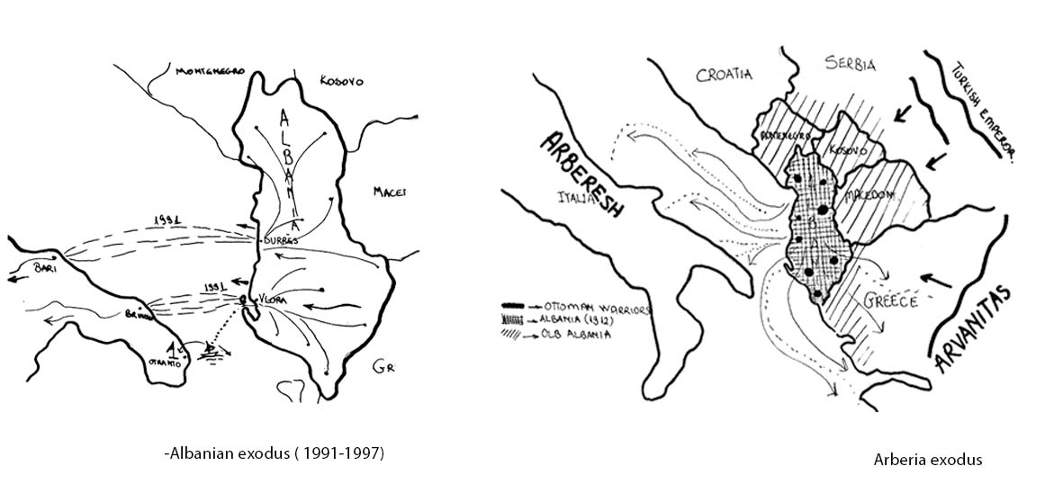

We don’t have to see only the bad side of the tragedy because of a tragedy countries can be the first attempt to connect them. “The truth hurts, but it also shrinks. Even in Albania has to be shown something because history can’t be vanish, young people will learn the story of their fathers (C. Gezim Zilja- Telegraph / 17 December 2011 'Kateri Rades Not only an Italian memorial)”

Relation Albania to Italy
Since the main focus of the theme is the interpretation of the tragedy that is related to the spiritual and human condition, a phase of the project will be precisely a connection, considering that in Albania and Italy there are a series of itineraries that have different functions such as tourist, religious,political, economic,there will be a guide that will have some programs that are intertwined with each other because if we see in a big scale meaning the reaction in Europe we can see a lot of mix itineraries along which it is seen that these one connect the east and west of continent.

As the road starts from Vlora and goes straight to Otranto, what is expected to continue above is the itinerary that reaches all the villages of Arberesh passing the region of Puglia, Calabria and Sicily. But part of the arberesh stretch to the central part, then the itinerary is divided and a branch goes to the Basilicata and Molise region.

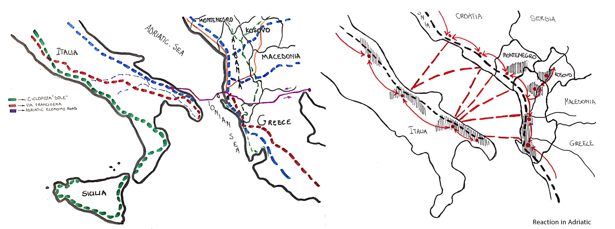

Itineraries category
In the initial reading of the Italian and Albanian regions results in 5 categories each having some specifics,but one of them prevails more than others:

1-Central and East Albania-tradition, tourism (mountain), landscape

2-West Albania and Italy coast-Economy, tourism (sea), landscape

3-Basilicata, Molise-Religion, agriculture, landscape

4-Calabria, Puglia -Culture, tradition, tourism (sea and mountain)

5-Sicilia- tradition, landscape, tourism (sea and mountain)

What will join these layers with each other arprecisely the respective one:

a-Underground system- TAP +IBNA

b-Sea- Tourism +Economic road of Adriatic

c-Field – Agriculture + tradition

d-Mountain – Bike, moto climbing and pilgrimage routes + landscape

System categories
There are going to be two kinds of systems. One is invisible and is focused on economy and exchange, while the other is visible and focused on tourism. Economic to connect east with west of Europe. Tourism is defined as the activities of persons identified as visitors (target group) .Those visitors are group who are making a visit to a main destination outside his/her usual environment for a period (time) for any main purpose (activities such as holidays, leisure and recreation )

Conclusions
The main idea of the project is to connect and to show a bridge of communication for countries even in different categories of join systems by “taking and giving ” to each other.

“After seeing the big scale and considering that the small scale of this project will be focus in Sazan Island as a key of the main purpose of thesis. The same idea goes even in this island, because there we find the same elements as in the big scale. Another important think of Sazan Island is that once he was the key of the Ionian and Adriatic Sea because of its history but now it’s forgotten from the rest.”

